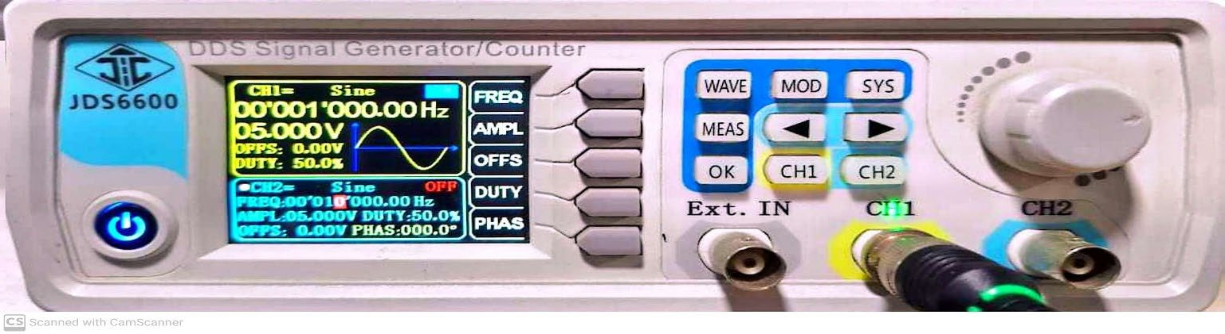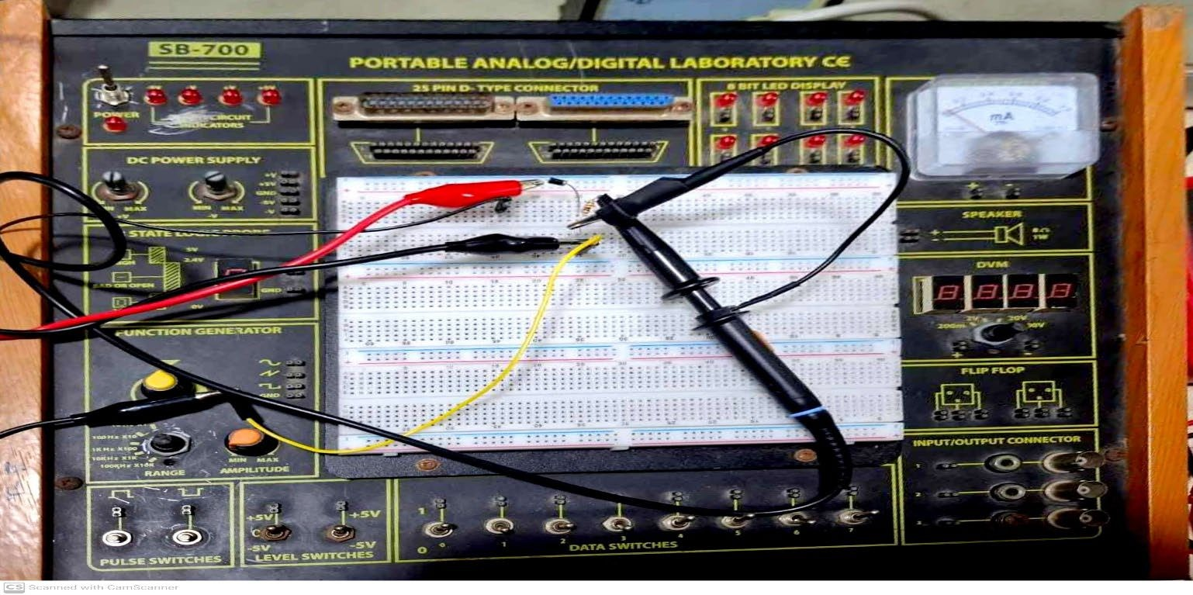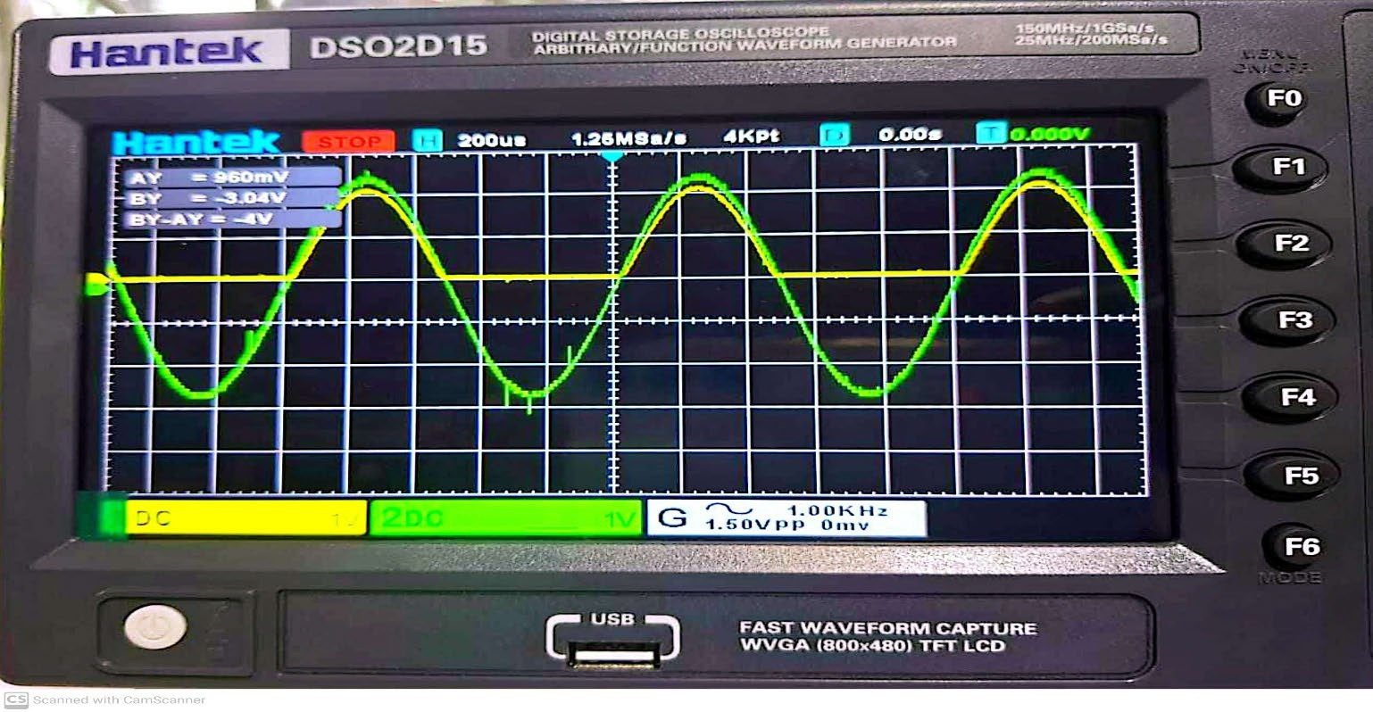

Fig-01: Input Voltage & Frequency in Signal Generator.

Fig-02: Half-Wave Rectifier Circuit in Trainer Board.

Fig-03: Input & Output Waveform in Oscilloscope.